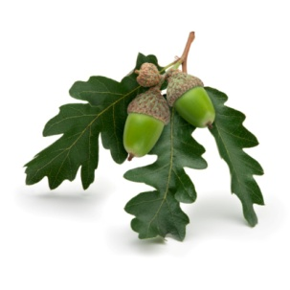

Oakwood Park Association Inc.

**AGENDA**

**Members’ Meeting**

**Sunday, July 1, 2012 10:00 am**

**Oakwood Inn**

**Agenda**

1. **Call to Order** – Nancy Dubois

1.1 Meeting Protocol – stand, name & address, name your motion, ask for seconder, discussion, avoid repeating comments

1. **Introduction of Board Members**
2. **Minutes of AGM held September 4, 2011**
3. **Presidents Remarks**

4.1 Comings and Goings

4.2 Member Directory

4.3 Web Site

4.4 Tree Committee (Arnold Sadler)

4.5 Notice Board at Gate

4.6 "Green Ribbon Award" for excellence in coastal stewardship

1. **Reports from the Board**

5.1 Secretary: Gerry Paulhus

5.2 Treasurer: Ray Hatherell (Bruce Hough, Past President)– Financial Update, 2011 Audit Decision

5.3 Security: Jim Young

5.4 Roads and Beaches: Jim Collez – Garbage Collection System

5.5 Nominating Committee: Bruce Hough – one vacant position now; one more in fall

5.6 OPEC: Debbie Kirkwood – Septic Standards

1. **Proposed By-law Changes**
2. **Other Business**
3. **Adjournment**